Justin Lorence P. Lagmay

Vince Matthew R. Jaramilla

**Introduction:**

A plant growth dataset package in R has been used to use it in one way ANOVA (1B) to determine if there’s any statistically significant difference between the means of two or more independent groups. The paper will involve descriptive and inferential statistics but will only scope the given data in csv.

**Method:**

To use one way ANOVA (1B) JASP we’re used, and the data was converted to csv to further be able to use for the graphs and its descriptive statistics and making analysis in the given results.

**Results:**

**Assumption Check**

Assumption 1: The dependent variable (weight) is at continuous level.

Assumption 2: The independent variable (group) consists of three categorical, independent groups (ctrl, trt1, trt2)

Assumption 3: Each observation is independent with each other as there is no relationship between the observations in each group of the independent variable or between the groups themselves.

Assumption 4: There should be no significant outliers in the three or more groups of your independent variable in terms of the dependent variable.

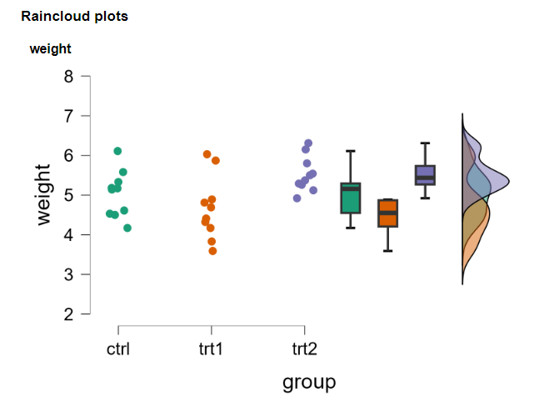

Based on the given data and outcome of the raincloud plots and boxplots, there are no significant outliers in the three groups of independent variables (group) in terms of the dependent variable (weight), as assessed by visual inspection of boxplots.

**Assumption 5: Normality Test**

Based on the given data, the weight is approximately normally distributed for each of the plants groups (ctrl, trt1, trt2), as assessed by Shapiro-Wilk’s test, p > 0.05.

**Assumption 6: Homogeneity of Variances**

Based on the given data, there was homogeneity of variances of the dependent variable for plant groups (ctrl, trt1, trt2), as assessed by Levene’s test of homogeneity of variances, p = 0.306.

**Computation**

**Discussion:**

A one-way ANOVA was conducted to determine if the weight of plants as they grow is different for various groups of plants. Plants were classified into three groups: ctrl, tr1, and trt2 *(n = 10 for each one)*. There were no outliers, as assessed by visual inspection of boxplot; data was normally distributed for each group, as assessed by Shapiro-Wilk test *(p > .05)*; and there was homogeneity of variances, as assessed by Levene’s test of homogeneity of variances *(p = .120)*. Data is presented as mean ± standard deviation. weight was statistically significantly different between plant groups, *F(2, 27) = 4.846, p = .016, $η^{2}$ = 0.264.* plant groups increased from trt1 (*M = 4.661, SD = 0.794)* to the ctrl (*M = 5.032, SD = 0.583),* and trt2 (*M = 5.526, SD = 0.443*) plant groups, in that order. Tukey post hoc analysis revealed that none of the the mean increases among the groups other than the difference between the trt1 and trt2 groups (*0.865, 95% CI [0.174, 1.556], p = 0.012*) were statistically significant.